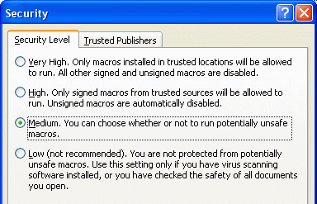
Lowering the Macro Security Setting
- Open Microsoft Word.
- Click Tools, Macro, Security.
- A Security box opens, as shown to the right on this page. Click the Medium button, and click the OK button. This step is necessary to allow Word macros to run.
- Close Word. Start Word again. This ensures that the security setting takes effect.
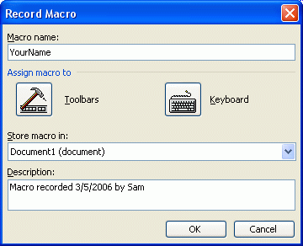

Recording a Macro
- Click Tools, Macro, Record New Macro.
- A Record Macro box opens, as shown to the right on this page. In the Macro name box, enter your first name (do not use any spaces). In the Store macro in: drop-down list box, select Document1. Then click OK.

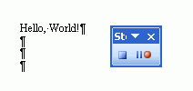
Stop Recording
- Your blank Word document is visible again. Type in Hello, World! and then press the Enter key a few times. Then click the Stop Recording button, as shown to the right on this page.
Viewing a Macro
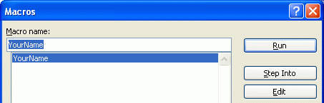
- Click Tools, Macro, Macros.
- A Macros box opens. Click on your name and click the Edit button.
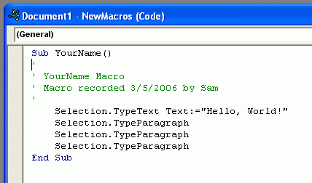
- A Document1 – NewMacros window opens as shown to the right on this page. There are several lines of text in this window starting with a Sub statement and ending with an End Sub statement. This is a Visual Basic Program. The Sub and End Sub statements indicate the start and end of this program, also called a Subroutine or a Macro.
- Notice the lines of green text starting with apostrophes. These are Comments – they have no effect on the operation of the program. They are just there to help the programmer stay organized.
- The Selection commands do the actual work in this macro – they type text on the screen. There are two types of Selection commands used here:
- Selection.TypeText – types in letters, as if you had typed them on the keyboard
- Selection.TypeParagraph – starts a new paragraph, as if you had pressed the Enter key
Running a Macro
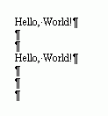
- Click the red X at the upper right of the Microsoft Visual Basic – Document1 window. The Visual Basic Program vanishes and your Word document appears again.
- Click Tools, Macro, Macros. In the Macros box, click on your name, and click the Run button.
- The macro runs, typing in another Hello, World! into your Word document, as shown to the right on this page.

Editing a Macro
- Click Tools, Macro, Macros.
- A Macros box opens. Click on your name and click the Edit button.
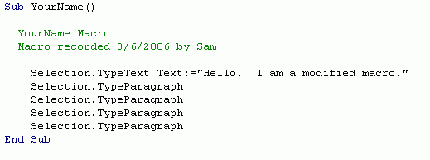
- A Document1 – NewMacros window opens. Find the line that has “Hello, World!” in it, and change that text to “Hello, I am a modified macro.” as shown to the right on this page. Be careful not to erase the quotation mark.
Running the Modified Macro
- Click the red X at the upper right of the Microsoft Visual Basic – Document1 window. The Visual Basic Program vanishes and your Word document appears again.
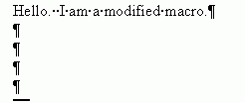
- Click Tools, Macro, Macros. In the Macros box, click on your name, and click the Run button.
- The macro runs, typing in Hello, I am a modified macro. into your Word document, as shown to the right on this page.
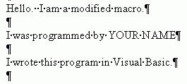
Creating Your Own Modified Macro
- Edit the macro again, to produce the output shown to the right on this page.
- Save the Word document on a floppy disk with any name you choose. Give the floppy to the Results Presenter.

Last modified 3-6-06

